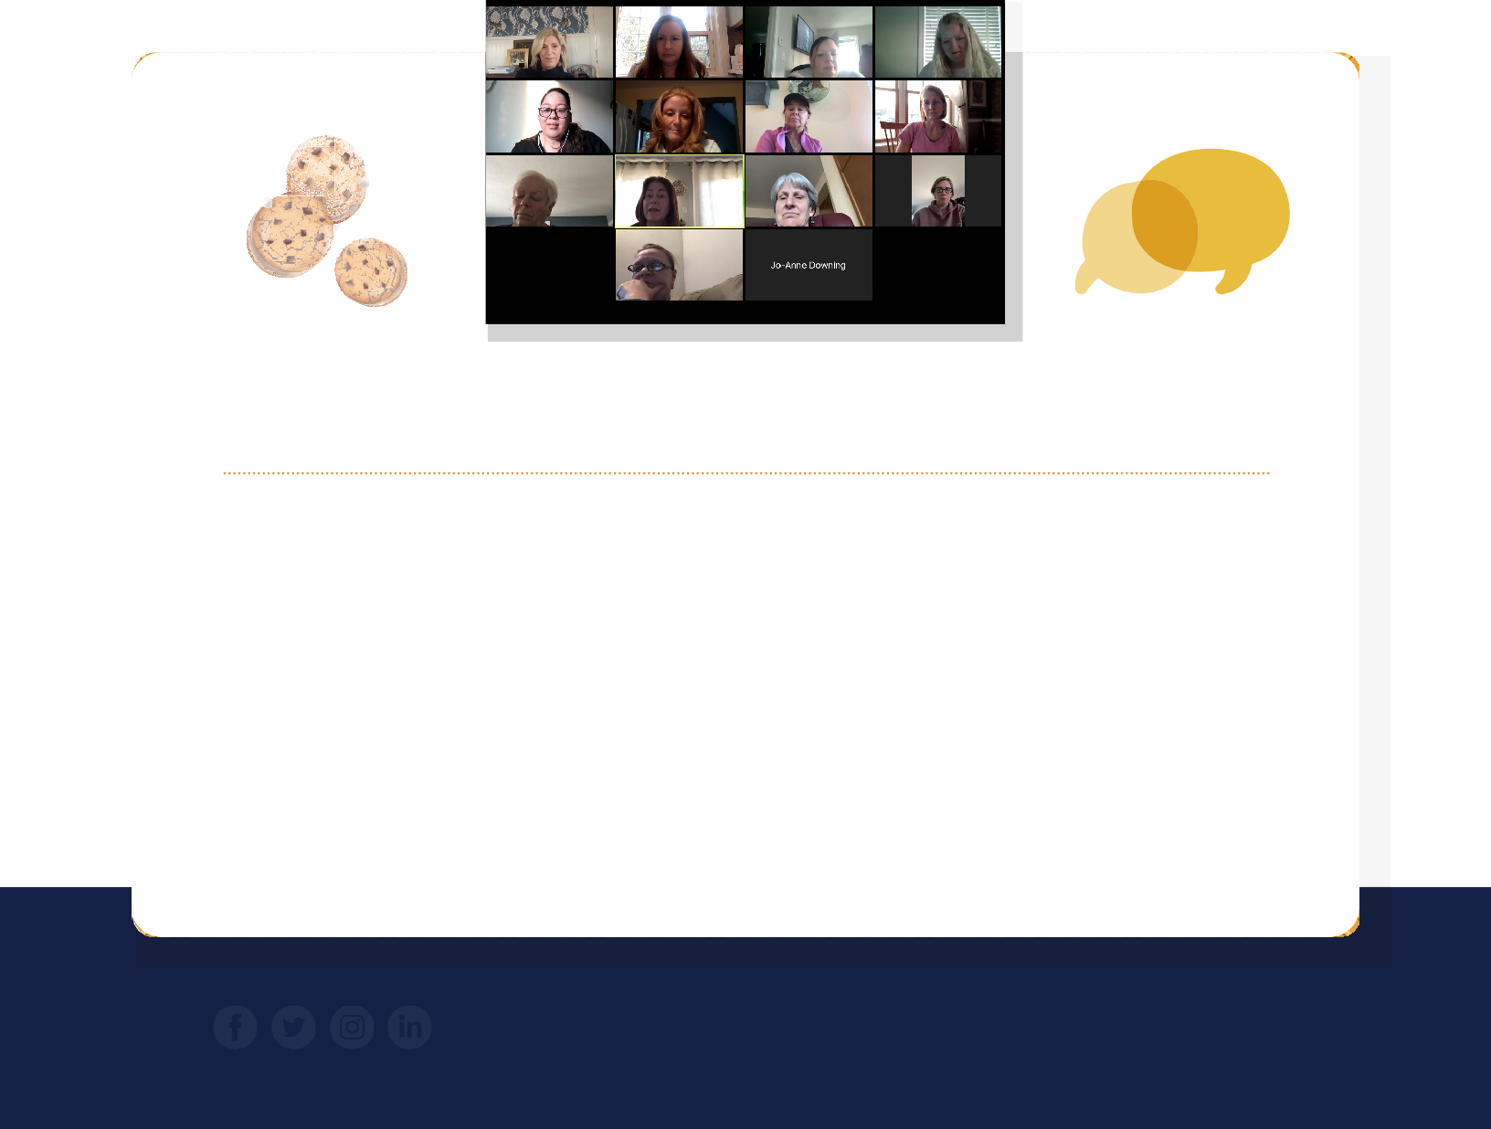

W E CA RE FOR T HOSE W HO CA RE FOR US
F
I
R
E

SPRING NEWSLETTER
.
T
P
E
D

Spring is here and we hope you are having a safe and healthy start to this new season.
Our Spring Newsletter is filled with exciting happenings from The Club.

With your generous support we continue to provide on-going, and life changing, benefits to more than 100 line-of-duty families and their children

“Cookies & Conversation”

This past year prevented The Club from holding many of its typical in-person events.
Recently, we were able to hold our first ever virtual event, “Cookies & Conversation”. The families are the fabric of The Club, and their stories of resilience and strength inspire us all on a daily basis.
“I really enjoyed being part of this “Cookies & Conversation” event.
It was a special opportunity to see longtime friends and to meet new survivors; And to express our gratitude for all the wonderful support The Club offers in our time of need.”
~ Kathy S.

FOLLOW US ON SOCIAL MEDIA FOR REGULAR UPDATES WWW.100CLUBMASS.ORG

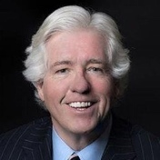
PRESIDENT’S MESSAGE

pring represents new beginnings and an emergence from the winter months. Here, at The Hundred Club, there are new beginnings to look
S
forward to, and wonderful memories to revisit.
In March, the first ever virtual event was held for the families of The Club. The cookies & conversation was a sweeping success and more virtual Zoom events will continue to engage even more of our Club families. As a result of this event and a survey sent to beneficiary families, The Club is evaluating some of the existing benefits and looks to add more support to the families we serve.
NEW BENEFIT & AFFILIATION
Home Base provides world-class clinical care, support, and wellness programs to Veterans, Service Members, and Families from across the nation who are impacted by invisible wounds at no cost to the Service Member.
This affiliation will provide services at no cost to current police officers and firefighters who are veterans, and to the families of The Hundred Club whose fallen heroes were military veterans.

FUNDRAISING
April launches The Club’s affiliation with the Home Base Program, a Red Sox Foundation and Massachusetts General Hospital Program. This affiliation will provide services at no cost to current police officers and firefighters who are veterans, and to the families of
The Club whose fallen heroes were military veterans.
Plans are underway for a summer event with The Club families. Your continued support and generosity make these events possible. We are forever grateful.
Peter Smyth, President

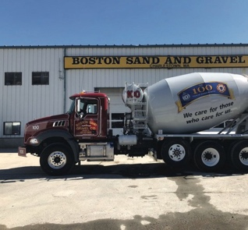
MEMBER HIGHLIGHTS THE BOYLAN FAMILY
The Boylan’s, owners of Boston Sand & Gravel, have been a corporate member of The Hundred Club for over 60 years. We are so grateful for their continued support and commitment to The Club.

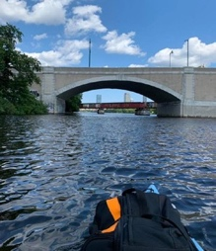
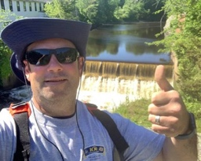
LIAM MCDERMOTT’S “57 FOR 100”
Fourth Annual B-Fit Challenge
This year’s B-Fit Challenge looked a bit different than previous years, as the event was entirely virtual! First responder, military, and community supporters made all the difference in making this year’s event a huge success. Over $275,000 was raised for charities to support police officers and firefighters.
Liam McDermott, a member of Greater Boston Firefighters
Pipes & Drums, is holding his 2nd fundraiser for The Hundred Club June 11th & 12th. Liam will kayak the 57 miles from his home to the head of the Charles River to raise awareness of The Hundred Club & the families we serve.

Thanks from our Families
THE CLUB LOST A LONG TIME MEMBER THIS YEAR.
IN MEMORIAM
“No one know the art of giving quite as well as you. The Dancing Deer box was a hit after our Sunday dinner. We all enjoyed it!”
Edward Carey
1945 - 2020

Mr. Edward Carey was a 42 year member of The Hundred Club.
Ed passionately supported The Club’s mission of caring for those who care for us. We are so grateful for the legacy he created through the recruitment of many family members and friends to club membership.

If you have not renewed your membership for 2021, it’s not too late. You can make your annual contribution to The Club securely through PayPal via our website or by mailing a check.
Laurie F.
“How do I begin to thank you for just remembering me. It is heartwarming that The Hundred Club is having a smooth changing of the guard. Congratulations to you Mr. President and Mr.

Chairman for your time, caring and generosity. You are the best and doing a wonderful job.” Mary Z.
MEMBERSHIP RENEWAL
“There are no words to express the appreciation that is felt for each of you and the organization. Your thoughts, support, and generosity at the time of my brother’s passing were extraordinary.”

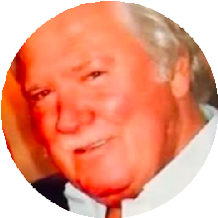
NEW MEMBERS
Any new memberships received will be applied to the 2021 calendar year.

GIVING
Please consider The Club in your estate planning. Planned gifts can have a lasting impact on the legacy of The Club. No gift is too large or small. You can have a significant role in securing the on-going benefits that The Club provides to those families who have lost a loved one in the line of duty.
Thank You For Your Support!
THE HUNDRED CLUB HAS LAUNCHED A BLOG.
Check out the latest happenings and profiles of community heroes at

100CLUBMASS.ORG/NEWS
Questions? Email at: General@100clubmass.org or Call:(617) 536-4410
Capt. James D.

“Thank you for your very generous and unexpected gift. Brian was a wonderful husband, amazing Dad, and loved being a Boston Firefighter. We appreciate
that his service to the city he loved is not forgotten.”
Ann D.

“Thank you for sending the treats from the Dancing Deer baking company. My Goodness!! Everything was
delicious. As always, it means so much to us that you remember and care.”
Kathryn S.

